|  |  |
| --- | --- |
| 1 | Population Calculation |

|  |
| --- |
| **Code** |

%Taking the inputs

p0 = input('Enter the population at time(0): ');

d = input('Enter time in which population will be double: ');

%Have to calculate at 5,10,15 years

t = [5 10 15];

l = length(t);

%Population calculation

for i = 1:l

temp = pow2( t(i) / d);

x(i) = floor( p0 * temp);

end

%Output

fprintf('\nThe populations at 5,10 and 15 years are gradulally \n%d %d %d\n',x(1),x(2),x(3));

%Drawing graph

hold on;

plot(t,x,'g*');

grid on;

xlabel('Years(t)'); ylabel('Population');

title('Population at different years');

|  |
| --- |
| **Output** |

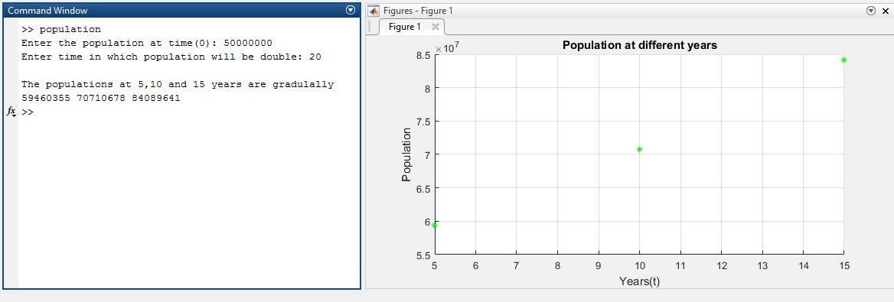

|  |  |
| --- | --- |
| 2 | Mass Damper System |

|  |
| --- |
| **Code** |

function spring_dumping_system()

time_span =0:0.001:18; %time in seconds.

k = 40; % spring stiffness. N/m

m = 5; % mass, kg

x0 = [0 0]; %initial_position & initial_speed

P = 100; % force amplitude

f=10; %unit step

c=3; %damping coefficient

[t,x]=ode45(@myFunction,time_span,x0);

plot(t,x(:,1),'g');

ylim([-.1 .5]);

grid on; xlabel('time'); ylabel('Displacement');

% solves m x''+ c x' + k x = f(t)

function xdot=myFunction(t,x)

xdot_1 = x(2);

xdot_2 = -(c/m)*x(2) - (k/m)*x(1) + f/m;

xdot = [xdot_1 ; xdot_2];

end

end

|  |
| --- |
| **Output** |

